**MEV key text**

**How to check resistance on the PS HV cable**

TSR states these checks should be performed once the truck is decommissioned by a level three Paccar trained technician.

TSR states the checks should be done by disconnecting the power steering cable from the power steering motor, use one lead on the metal housing of the connector on the HV cable and put the other lead on the nearest known to be good bonding point and check for resistance. Once verified there is resistance, please shake the cable to see if resistance changes and document the measurement before and during the shake test.

**Blue horizons update 0.34. and SW update**

The latest software update for PB579EV and T680E trucks (SCM_1p5_AC_R5p00_003) has been released for PACCAR dealers to update trucks using the Blue Horizon diagnostic tool.

Dealers will need to login to the Snap-On website and download version 34 of the Blue Horizon Tool prior to reflashing SCM/PCM software on trucks.  Once they have version 34 of the diagnostic tool loaded onto a laptop and are connected to the internet, they can follow the directions in TP-2246 which will walk them through reflashing the truck.  The reflash will need to be coordinated with the update of the Bendix module as well.

Click on this link to download a copy of TP-2246:  [TP2246.pdf (graphicvillage.org)](https://graphicvillage.org/meritor/TP2246.pdf)

The dealer will also need to contact OnTrac and open a case to document the update and allow them to get paid for the labor.  The Technical Publication, TP-2246 also addresses a shift actuator performance improvement which is administered through a PCM software update which we rolled out last October. To ensure the truck does not experience premature failure of the shift actuators, the OnTrac representative may direct the dealer to order replacement shift actuators based on the odometer reading at the time of software update.  There is no need to down the truck while the dealer is waiting for the shift actuators to be delivered; they can be replaced when they come in.

Please review the technical publication and let me know if you have any questions or concerns.

**Return address:**

Priority 1

2057 Aldergrove Ave.  Escondido CA 92029

(760) 294-8037

https://www.concursolutions.com/nui/travelrequest/request/813720214A4F73499D912831E3FE1282

Priority 2

Harold Meyer  
2415 Auto Park Way  
ESCONDIDO CA 920291222

619-922-5216

**Clearing DTCs sequence**

while key ON clear faults -> key off -> wait at least a minute -> key ON -> pull faults again

**Electric diag**

**isolation fault won't trigger till the value is less than 700Ohm/V**

Chris was following the troubleshooting tree regarding the fault a commented on looking into the LV Harness going to the PDU. Since I was on the phone with him, I confirmed the steps he needed to take by verifying the pins at the PDU LV Connector back to the LVDS Connector to ensure the feedback was closed. If the negative contactor feedback circuit at J65.1 with the connector removed has continuity/resistance to chassis, then the contactor is closed/stuck. With the connector removed if it doesn’t have continuity to chassis then the issue could be inside the LVDS to the SCM Controller.

I also informed him if while measuring the feedback for that circuit if they removed the PDU LV Connection and they still have continuity or resistance to chassis then the issue is in the harness.

If they did have continuity from the J65.1 to the PDU then they could verify if the HV side of the contactor is closed by checking either continuity/resistance ESS 1 or 2 HV – (B) to INV 1 or 2 HV – (B). If they have continuity/resistance, then the HV side of the contactor is welded/stuck.

He is going to have the technician verify the circuit as this unit is supposed to go to an expo/event for them tomorrow.

He will reach out as well as give me an update.

Please let me know if you have any questions or concerns.

**ACC light on after R5.003 update.**

FYI, if you get an ACC light on after R5.003 update, the following procedure has shown success in clearing it:

1. With ignition ON, depress the brake pedal and hold down for 30 seconds. Release the brake pedal.
   1. That will calibrate the brake pressure sensor and should inactivate the 409-184 fault in the ABS controller.
   2. That will also clear the ACC error message on the dash and inactivate the ACC fault code in BlueHorizon
2. Clear all faults using Bendix ACOM Pro
   1. Note: It’s expected to have certain CAN faults. All of the active CAN faults on your original ACOM report are normal and are caused by the ABS ecu looking for diesel engine messages that aren’t being sent. These won’t cause dash lamps.
3. Clear all faults using DAVIE4
   1. Note: It’s expected to have certain CAN faults. All of the active CAN faults on your original DAVIE4 report are normal and are caused by the VECU looking for diesel engine messages that aren’t being sent. These won’t cause dash lamps.
4. Clear all faults using BlueHorizon
   1. We sometimes see inactive CAN faults which is related to the ECU powerdown sequence (one ECU powers down first and stops sending a certain message).
5. Turn the ignition off and battery disconnect off.
6. Let it sit for 5 minutes.
7. Turn the battery disconnect on and ignition on.
8. Check for dash lamps.
   1. If dash lamps exist, reply to this email with which lamps are on.
   2. If no dash lamps exist, continue to next step.
9. Test drive truck and ensure no dash lamps return.
   1. If dash lamps exist, reply to this email with which lamps are on.

**PDU contactor meeting on Wednesday**

[**https://teams.microsoft.com/l/message/19:45e2e5a6105c44cdaa77749998c633fe@thread.v2/1689625971853?context=%7B%22contextType%22%3A%22chat%22%7D**](https://teams.microsoft.com/l/message/19:45e2e5a6105c44cdaa77749998c633fe@thread.v2/1689625971853?context=%7B%22contextType%22%3A%22chat%22%7D)

**Issue tracker sheet**

[Accelera PD8500 Service Engineering (External Sharing Enabled) - 05_Infant Care - All Documents (sharepoint.com)](https://cummins365.sharepoint.com/sites/GRP_CC52040/Shared%20Documents/Forms/AllItems.aspx?ga=1&OR=Teams%2DHL&CT=1690919380423&clickparams=eyJBcHBOYW1lIjoiVGVhbXMtRGVza3RvcCIsIkFwcFZlcnNpb24iOiIxNDE1LzIzMDcwMzA3MzMwIiwiSGFzRmVkZXJhdGVkVXNlciI6ZmFsc2V9&id=%2Fsites%2FGRP%5FCC52040%2FShared%20Documents%2FGeneral%2FPD8500%2F05%5FInfant%20Care&viewid=86a1f38b%2D3ea1%2D444f%2Dbd51%2Dc850bf52d7e5)

Link that dealer firewall has to pass through   
  
And also, they should have read/write privileges

<https://meritor.diagsys.com>  
  
  
* Cabin heater replacement key txt :   
  
TSR states that this case is created to document Cabin heater replacement campaign (C23AF)

TSR states that please ensure vacuum fill procedure is followed as mentioned in MM21106(<https://graphicvillage.org/meritor/MM21106.pdf)> Page 21.   
TSR requests facility to place a unit down PACCAR order for P/N " CPTFRK6492628 "

Facility to provide updates of the replacement and final invoice for review. TSR updated the case

**PDU contactor weld reasoning from Mike Z**

A loss of isolation would provide the driver with audible & visible alarms but would not shut the vehicle down.  A Stop Engine Immediately lamp and the loss of HV isolation tell-tale would be illuminated on the dash.

Since this vehicle does not appear to have a loss of isolation issue, I would not be investigating isolation.

**Also,**

Attached are two separate check lists.  I originally created the "Technical Report of a contactor issue" for **any** contactor failure.  Ian had used that to create "Contactor Fault Troubleshooting" .doc for service.  While he mentions a scenario where we *may* have a loss of isolation, a dead short, and a failed contactor at the same time, this is generally caused by water intrusion and/or phase-to-phase short circuits.   The short circuit would have taken out the contactor and possibly fuses, but the water intrusion (or a loose piece of hardware) was the cause for the loss of isolation.

 If you don't have an active loss of isolation alarm on the dash, in raptor, or anywhere else, skip the isolation and cable checks and continue with the Technical Report of a contactor failure.  Once completed, the information contained in the report is far more useful in allowing engineering to provide assistance.

information such as:

* Dates, Time, and temps
* 12V voltage
* active SCM faults/Raptor Faults/Viricity fault
* PDU serial numbers
* Driver’s comments of how/when the fault occured
* PDU coil resistances (static)
* PDU auxiliary contact resistances (static)
* Auxiliary fuse continuities
* HVIL continuity (dynamic/ cable shake tests)
* Contactor 12V+ supply continuity (dynamic/ cable shake tests)
* Contactor 12V return continuity (dynamic/cable shake tests)

Have a call, need to drop.

**PCM part number**

**PCM part # 111186 ASSY, PCM, INTEGRATION KIT, 2.1M PCM/SOFTWARE**

SCM part P06

34 CPT110842 Harness, LV and Controls, Plate to PCAS 1 according to the parts book

**Moving forward, all failed field PDU’s will be returned to the following address: CEP.**

ATTN: Melony Bean

Address: 500 Central Ave, Dock 72, Columbus, IN 47201

**QSOL instructions:**

TSR states if you need a wire schematic, please visit QSOL at the link below.

https://quickserve.cummins.com/info/index.html

Please select the following product info.  
BES CM0196 EV114B  
  
**QSOL DTC instructions:**  
  
TSR states please work through Quick Serve Online and TCS to resolve this issue. If QSOL is missing information to help you fix this unit please reach out to OnTrac and submit a ticket through QSOL to update the trouble shooting. IF you cant resolve this issue with QSOL or TCS please reach out to OnTrac for help.

https://quickserve.cummins.com/info/index.html

BES CM0196 EV114B

TSR updated the case and emailed the case to the facility.

**Troy return address:**

*Please label all the parts correctly and with the correct OnTrac case number (very important). Also, use ground service for all the return items.  
Once completed, please send the invoice and the tracking number to OnTrac for authorization.  
  
Return address:

Cummins-Meritor  
ATN Poorvak Patel B264 /Joel Mitchell B272 (PLEASE PUT THE CORRECT ONTRAC CASE NUMBER HERE)  
2135 W Maple Rd, Troy, MI 48084  
1-866-668-7221.

Ontrac Phone #

1-866-668-7221

**Return alt key text.**

*Please label all the parts correctly and with the correct OnTrac case number (very important). Also, use ground service for all the return items.  
Once completed, please send the invoice(including return freight) and the tracking number to OnTrac for authorization.

All epowetrain componentes(Inverters,shift actuators, e-motor, and powertrain cables) will go to following address :

ATN Poorvak Patel B264 (PLEASE PUT THE CORRECT ONTRAC CASE NUMBER HERE)  
2135 W Maple Rd, Troy, MI 48084  
1-866-668-7221

All other items will need to be returned to the following address:

ATTN: Melony Bean (PLEASE PUT THE CORRECT ONTRAC CASE NUMBER HERE)  
Address: 500 Central Ave, Dock 72, Columbus, IN 47201

Let me know if you have any questions/concerns.

**R5.007 SCM reflash request**

After reflash -> home -> info -> select SCM-> take a screenshot of SCM software level for R5.007 and send it to OnTrac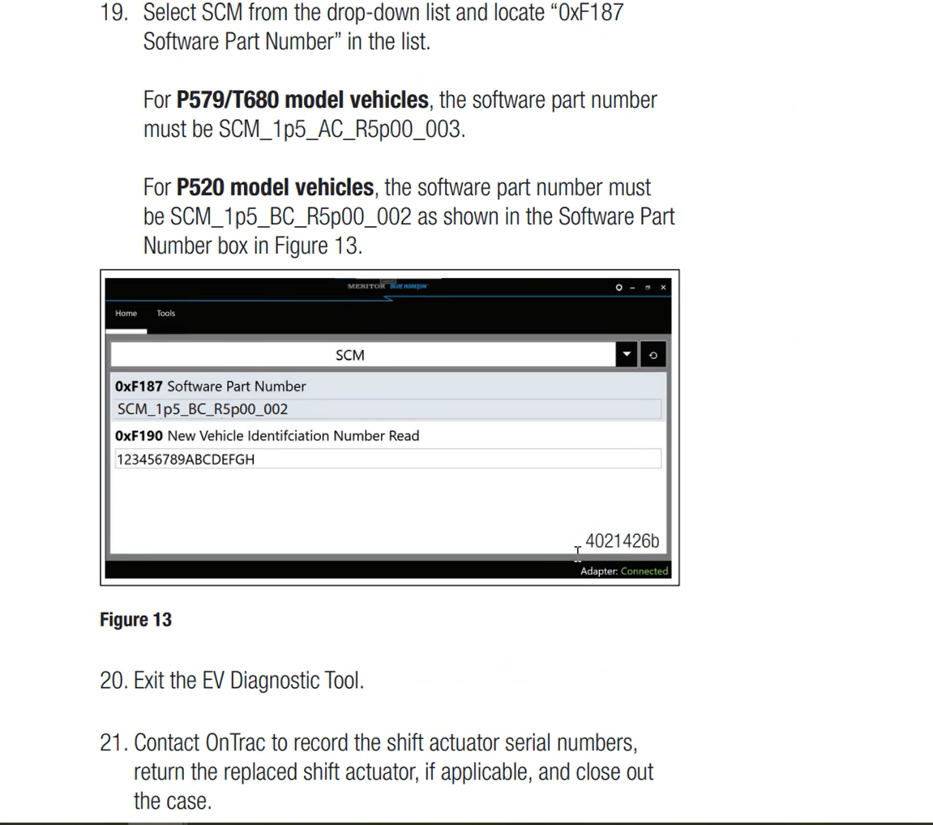

**MPX Parts dept**

1-888-725-9355

**Keytxt**

Need to drop, have a call.  
  
 **Copper paste keytxt**  
  
TSR states please ensure 12V is turned off while making or breaking any connection with connectors or bonding / grounding straps. Please use the copper paste HCG or CP8-TB.

TSR states this paste can be bought through Grainger at the link below.

<https://www.grainger.com/search?searchQuery=thomas+%26+betts+CP8TB&searchBar=true>

**correct Key cycling sequence**Key on -> clear faults -> Key off -> wait 1 min -> Key ON -> Pull faults to confirm if fault is present(please provide screenshot)